Delete equipment

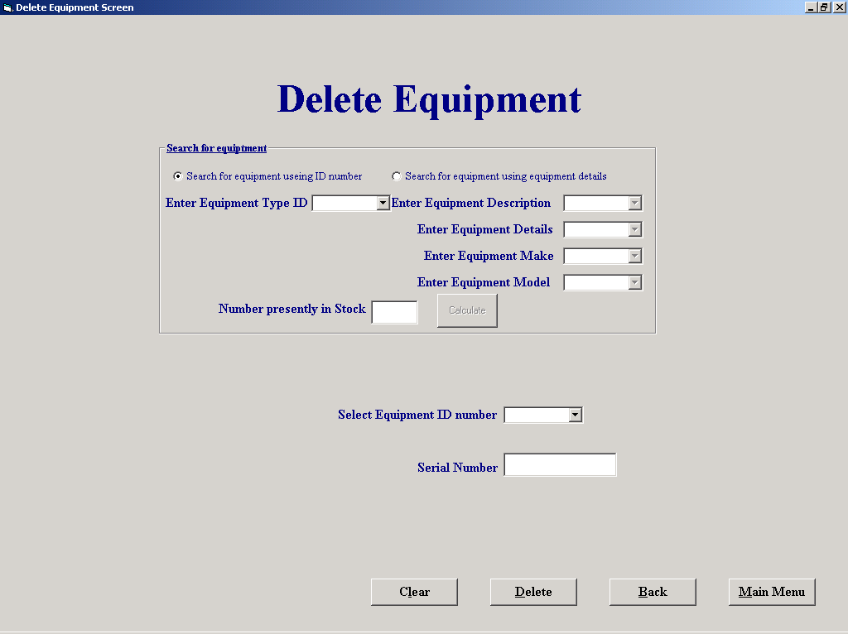

Purpose of the screen

This form allows the user to select a piece of equipment for and mark its record for deletion. If the user knows the equipments ID number he can input it in a text box and then confirm it's serial number and then delete it (If the piece of equipment is out on hire then it should not be deleted) Alternatively you can search for the ID numbers of all stock by selecting either their Type ID number or working your way down a number of selection steps to search the a unique type. Each step you take reduces the scope of your search. When you have chosen the type you require you can calculate the number in stock and add the ID numbers to drop down list of a combo box

How to get to the screen

This screen is opened by selecting the “File Maintenance” button on the main menu, then the “Equipment File processing” button on the File Maintenance menu followed by the “Delete equipment “Button.

How to use the screen
- To search for a piece of equipment and to confirm it is in stock and it can be deleted you must search using known information about the type of equipment being searched for. This search can be carried out in one of two ways either by using the type ID or the Description, Details, Make and Model of the piece of equipment.
- To use the Type ID select the “Search for equipment using ID number” option

- Then either
- View a list of all possible ‘Equipment Type Ids’ available by selecting the down arrow on the right of the data input box marked “Enter Equipment Type ID”
- Then select a ‘Type ID Number’ by clicking on it
- When a ’Type ID Number’ has been selected it will appear in the data input part of the input box
- Or
- Enter the ‘Type ID’ of the equipment of in the “Enter Equipment Type ID” data input box

- To search by the Description, Details, Make and Model of the piece of equipment select the “ Search for Equipment using equipment details” option
- Then
- View a list of all possible ‘Equipment Descriptions’ available by selecting the down arrow on the right of the data input box marked “Enter Equipment Description”
- Then select the ’Description’ of the required piece of equipment by clicking on it
- When a ’ Description’ has been selected it will appear in the data input part of the input box
- Then
- View a list of all possible ‘Equipment Details’ available (where the ‘Description’ matches the ‘Description’ already chosen) by selecting the down arrow on the right of the data input box marked “Enter Equipment Details”
- Then select the ’ Details’ of the required piece of equipment by clicking on it
- When the ’ Details’ have been selected they will appear in the data input part of the input box
- Then
- View a list of all possible ‘Makes of the Equipment’ available (where the ‘Description’ matches the ‘Description’ already chosen and the ‘Details’ match the ‘Details’ already chosen) by selecting the down arrow on the right of the data input box marked “Enter Equipment Make”
- Then select the ’ Make’ of the required piece of equipment by clicking on it
- When the ’ Make’ has been selected it will appear in the data input part of the input box
- Then
- View a list of all possible ‘Models of the Equipment’ available (where the ‘Description’ matches the ‘Description’ already chosen and the ‘Details’ match the ‘Details’ already chosen and the ‘Make’ matches the ‘Make’ already chosen) by selecting the down arrow on the right of the data input box marked “Enter Equipment Model”
- Then select the ’ Model’ of the required piece of equipment by clicking on it
- When the ’ Model’ has been selected it will appear in the data input part of the input box
- Also at this stage the ‘Equipment Type ID’ will appear in the “Enter Equipment Type ID” data input box
- Select the “Calculate” button to display the number of items of stock, which match the search criteria, are available to hire. The result of this check on stock is displayed in the “Number Presently in stock” data input box.
- If the “Number Presently in stock” data input box displays a zero there are no matches of the search criteria available to hire and a new selection process can be started.
- If the “Number Presently in stock” data input box is not displaying a zero the ‘Equipment ID’ numbers of any equipment that matches the search criteria are loaded into the drop down list of the “Select Equipment ID Number” data input box

- View a list of all ‘Equipment IDs’ available by selecting the down arrow on the right of the data input box marked “Select Equipment ID Number”
- Then select the ‘Equipment ID’ of the piece of equipment retrieved from stock (Every piece of equipment should be marked/engraved/tagged with its unique ID number) by clicking on it
- When the ‘Equipment ID’ has been selected it will appear in the data input part of the input box
- The task of selecting an ‘Equipment ID’ by clicking on it will enter this piece of equipments serial number into the “Serial Number” input box. This can then be used to confirm the equipments ID before deletion.

Alternatively

- If the piece of equipment is available you should be able to read the equipment number of the equipment (Every piece of equipment should be marked/engraved/tagged with its unique ID number). This can be entered into the “Select Equipment ID Number” input box and the serial number will be displayed in the “Serial Number” input box. This can then be used to confirm the equipments ID before deletion.
- This method is more likely to create errors as there is no check on present status so there is a couple of forms of error handling message box that will appear if an error is made
- If the status of the equipment is ‘Out’ i.e. the equipment is currently recorded as on hire then a message box will appear to inform you of this.

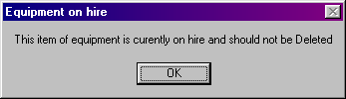

- If there is no record of the equipment then a message box will appear to inform you of this.

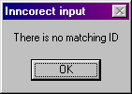

Select the “Delete”(alt-D) button to delete the displayed data a message box will appear to confirm that you require this equipment.

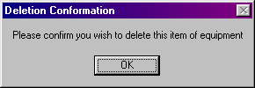

- Select the “Clear”(alt-C) button to clear the data displayed
- Selecting the “Main Menu”(alt-M) brings you to the Main menu if there is undeleted data in the screen you will be prompted to delete it now it with a message box

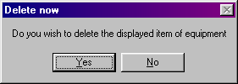

- Selecting the “Back”(alt-B) button brings you to the screen that you were in prior to this one the “Delete now” message box also appears.

